

WEB BASED INTERFACE DESIGN
CSF3133

LAB REPORT 6
NAME: MOHAMMAD AIMAN BIN ALIAS
MATRIC: S75686
DATE: 4.12.2026
PROGRAMME: COMPUTER SCIENCE
(SOFTWARE ENGINEERING)

6.4 firstjs.html
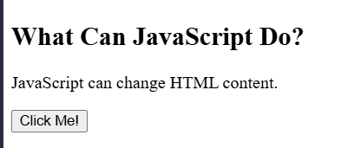
6.5 datetimejs.html
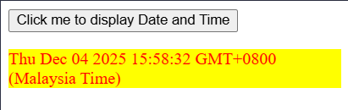
6.6 changelight.html
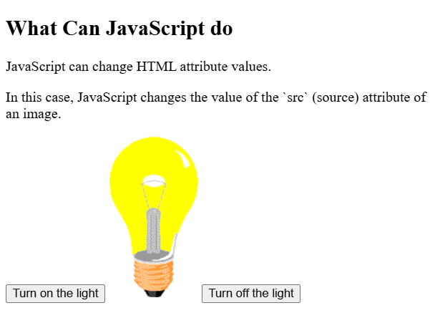

6.7extjavascript.html
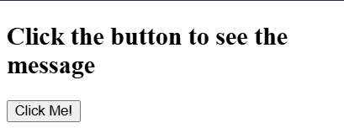
6.8 disable-right-click html
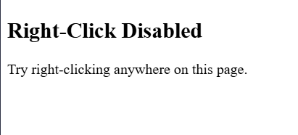

6.9 mutiplication-table html
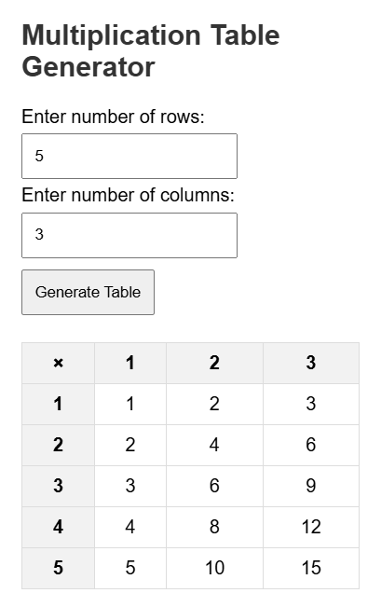
6.10.1 form-validation html
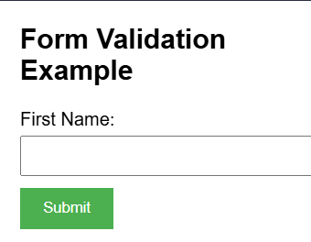
6.10,2 numeric-validation html
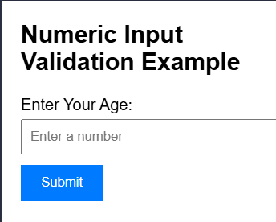

Case 1: leave empty
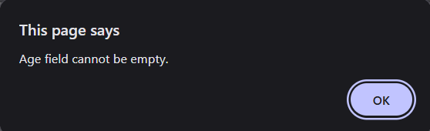
Case 2: non numeric character
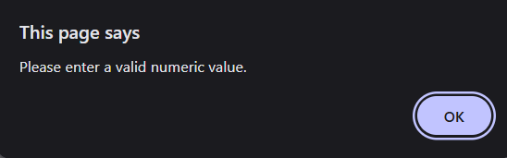
Case 3: number outside range
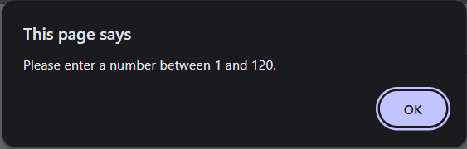
Case 4: valid number
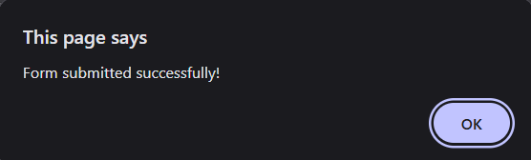
6.11 guess-number html
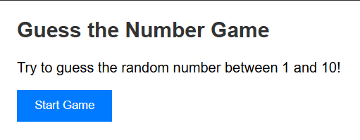

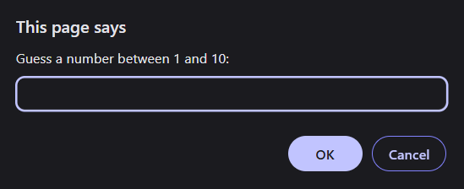
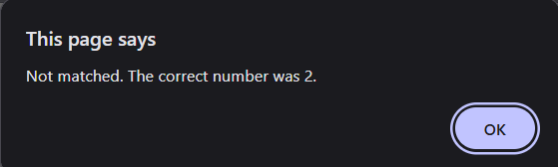
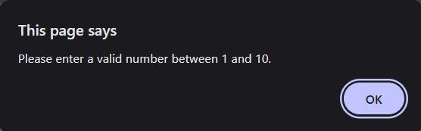

LAB EXERCISE
